Graph isomorphism problem

The term “isomorphic” is applied to a graph when the number of components (vertices and edges) are the same and Their edge connectivity is relatively the same. In the following example below, we will explain in detail what this means.

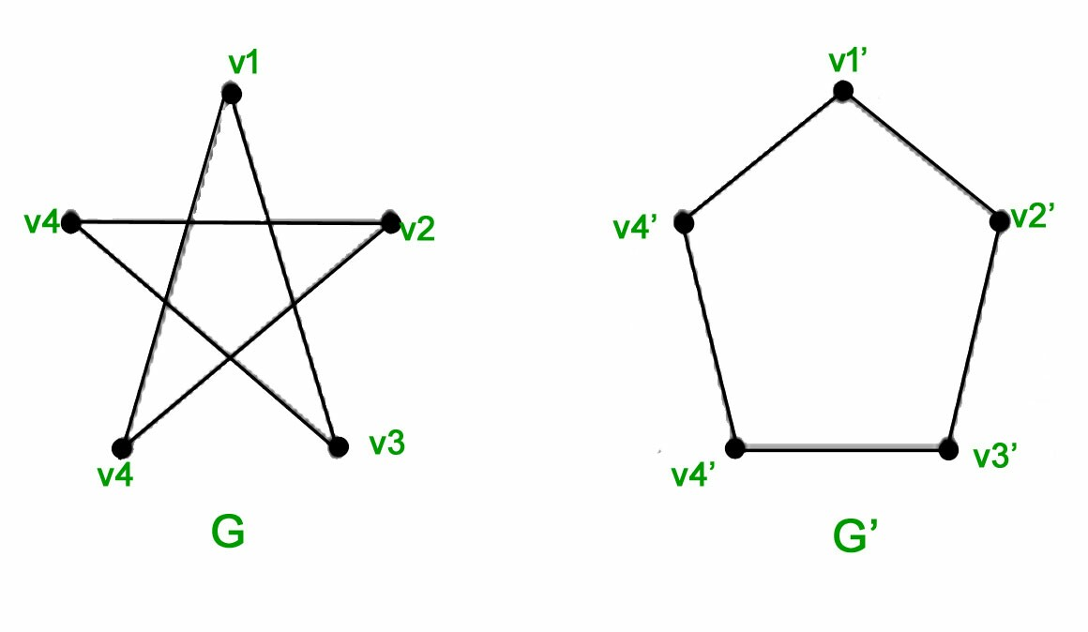

In the diagram above there are two graphs, G (the star) and G1(the pentagon).